March 13, 2024

SENT VIA EMAIL &
CERTIFIED U.S. MAIL

Mr. Blake Paterson
bpatersongop@fastmail.com

Re: Grievance In Re: Blake Paterson

Dear Mr. Paterson:

This letter is to inform you that after careful consideration and pursuant to Republican Party of Florida (“RPOF”) Rule 22, I have accepted the unanimous recommendation of the Grievance Committee (“Committee”), attached hereto, regarding two grievances filed against you. RPOF Rule 22E. states, “If the Chairman approves the recommendations, they are adopted and become final.”

Therefore, effective immediately:

- You are hereby removed as Chairman and as Precinct Committeeman of the St. Johns County Republican Executive Committee (“St. Johns GOP”).

- You are prohibited from holding any position within the St. Johns GOP, the RPOF, or any RPOF chartered club in St. Johns County for a period of two (2) years. As such, you are also not eligible to be a member of the RPOF State Executive Committee, the RPOF State Executive Board, nor hold any position within a RPOF Congressional District Caucus for two (2) years.

- A vacancy now exists in the office of St. Johns GOP Chairman. § 103.131, Fla. Stat. St. Johns GOP Vice Chair Jamie Parham shall assume the duties of Chairman on a temporary basis and shall call for an election to fill the vacancy in the office of Chairman as soon as possible, but no later than sixty (60) days, while abiding by all required notice requirements. The person elected shall fill the remainder of your unexpired term as Chairman.

Sincerely,
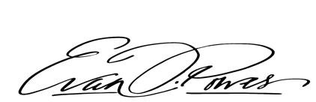
Evan J. Power
Chairman

Enc: Grievance Committee Recommendation

Cc: Roy Alaimo; Jaime Parham; Mark Cross, Chair, RPOF Grievance Committee; RPOF Grievance Committee; George Riley, RPOF Executive Director;
Benjamin J. Gibson, RPOF Chief Legal Counsel

